**Inbreeding and sex allocation in hermaphroditic metapopulations**

Camille Roux, Charles Mullon, Samuel Neuenschwander, Jérôme Goudet, John R. Pannell1

Department of Ecology and Evolution

Biophore Building

University of Lausanne

1015 Lausanne

Switzerland

email: john.pannell@unil.ch

KEY WORDS:

SHORT TITLE:

**Introduction**

‘Sex allocation’ refers to the proportion of reproductive resources an individual invests in its male versus female sexual functions. In dioecious or gonochoristic species, it is synonymous with the sex ratio of sons and daughters produced by mothers, weighted by the relative cost of raising an offspring of each sex to independence. The fact that many species appeared to produce equal sex ratios once seemed puzzling, as males would appear to be a wasted resource from the perspective of the potential intrinsic growth of a population. Although the German biologist Karl Düsing {, 1884 #5061} first provided an evolutionary explanation for equal sex ratios, the idea is often credited to Ronald Fisher {, 1930 #275}. Simply put, because autosomal genes have an equal chance of passing to the next generation through male and female gametes, selection should favour investment in the success of each of these two paths. The corollary is that, in populations with an unequal sex ratio, selection will favour alleles in the minority sex, because they must, on average, leave more progeny than those of the majority sex. In such populations, natural selection should thus rapidly bring about an equilibration of the sex ratio.

Although equal sex ratios are common, many species produce female-biased sex ratios, with more daughters than sons. William D. Hamilton {, 1967 #349} explained these ‘extraordinary sex ratios’ largely in terms of the effects of ‘local mate competition’, which violates the assumption of random mating made by Düsing and Fischer. If mating is not random, and, in particular, if sons must compete among themselves for mating with a restricted number of females, selection should favour a strategy that biases the sex ratio towards the production of fewer sons and more daughters. Hamilton’s {, 1967 #349} explanation is supported by a wide range of empirical observations, and indeed stands as perhaps the most successful cornerstone of life-history theory {reviewed in \West, 2009 #5794}. It is particularly well illustrated by examples where the sons and daughters of a small number of fertilized females hatch together and mate before dispersing; when the number of mothers is small, the chance of mating between full or half siblings (inbreeding) is high (REFS). Indeed, the inbreeding coefficient, which measures the degree to which related individuals mate with one another relative to the case of random mating across the population, is a reliable predictor of sex ratio chosen by mothers for their progeny (REFS).

While the above ideas were developed principally with gonochoristic species in mind and have found substantial support from studies of species with separate sexes (REFS), they also apply to hermaphrodites (REFS). Hermaphrodites do not generally produce sons or daughters, but their sex allocation can be viewed in terms of the relative investment they make to their male versus female functions, e.g., to sperms versus eggs or, for plants, to pollen versus seeds – even though these relative investments may be difficult to compare directly (see Discussion). Just as for species with separate sexes and sex ratios, selection on the sex allocation of hermaphrodites should favour equal investment in both sexual functions if mating is random and both pollen and seeds are widely dispersed. Indeed, limited dispersal can cause sib competition, and theory predicts that the sex ratio should be biased in favour of the sex that shows the smaller degree of competition between siblings (Clarke 1978; Bulmer and Taylor 1980; Frank 1986). (Although it is often supposed that hermaphroditic plants invest more heavily in their female function, which involves both flower, seed and fruit production, measures of the cost of male investment in terms of trade-offs with growth show that it, too, can be high and can equal or even surpass the costs of female function; {Harris, 2008 #5607}.)

Just as for dioecious species or gonochorists, hermaphrodites in populations subject to local mate competition are expected to bias their sex allocation to their female function. Thus, female-biased allocation is predicted for plants where pollen is dispersed to limited number of receptive flowers, over small distances than are seeds {Lloyd, 1982 #523}. Similarly, female-biased allocation is predicted for partially inbreeding hermaphroditic populations, whether through self-fertilization or biparental reproduction (REFS). The expected female-biased sex allocation of inbreeding hermaphrodites is well supported by empirical data, particularly comparisons between populations or species that have different rates of self-fertilization. For instance, plant populations that have undergone a transition from outcrossing to selfing often quickly evolve a ‘selfing syndrome’, which includes reduced allocation to pollen and traits that play a role in pollen dispersal {Lemen, 1980 #490} REFS. Although this has been attributed to the ‘greater efficiency’ of self-fertilizing plants {Cruden, 1977 #197}, their reduced allocation to male function is better seen as an illuminating example of selection under local mate competition (or ‘local sperm competition; {Schärer, 2009 #5724; Scharer, 2013 #6593}, where pollen grains (or sperm) from the same individual compete to fertilize its own restricted pool of ovules (or eggs).

Self-fertilization represents the most extreme form of inbreeding, but strong population structure can also bring about inbreeding (REFS). In demographically stable plant populations in which seeds and pollen are dispersed over short distances, mating partners will often be more closely related than individuals drawn randomly from the population, but the levels of inbreeding brought about by such population viscosity are relatively mild compared with self-fertilization (REFS). By contrast, we might expect species subject to metapopulation dynamics, i.e., frequent local extinctions and recolonisations, to show high levels of inbreeding, too. For instance, populations founded by single self-fertile individuals may grow to large local sizes over the course of a few generations by self-fertilization (REFS). Even if mating is random within such (potentially large) populations, all individuals will be closely related through their descent from a single recent coloniser, and we should expect the inbreeding that results from such metapopulation dynamics to influence selection on the sex allocation (REFS). In particular, we should expect metapopulation dynamics to bring about selection for female-biased sex allocation in hermaphroditic species. To our knowledge, this prediction has not yet been examined in any detail. How rapid must population turnover be before we should expect an appreciable shift in the sex allocation of a hermaphroditic metapopulation? And what index of inbreeding would be the best predictor of the sex allocation selected?

Here, we use quantitative genetic simulations of hermaphroditic metapopulations to demonstrate that population turnover should select for female-biased sex allocation as long as migration among demes is insufficiently strong to erase the genetic signatures of inbreeding brought about by colonisation. Moreover, we find that the inbreeding coefficient *F*ST is a much better predictor of the sex allocation selected in such a situation than *F*IS, which has proven adequate to predict the sex allocation within single viscous populations, as noted above. Although the importance of *F*ST as a predictor of sex allocation in metapopulation has hitherto not been emphasised, our result should be intuitive: what brings about local mate competition in a metapopulation is the effect of extinctions and colonisations on population differentiation, which is well described by *F*ST. Interestingly, our simulations also indicate that Jost’s D {, 2008 #6080} is a poorer indicator than *F*ST of when to expect selection to shift the sex allocation of a metapopulation. There has been substantial discussion in the literature about the relative merits of Jost’s D versus *F*ST (and its multiallelic equivalent, *G*ST) as measures of genetic differentiation (REFS). While the results of our study do not address this issue directly, they do resonate with the view {e.g., \Whitlock, 2011 #6072} that *F*ST should be a preferred measure of genetic differentiation when we wish to draw from it inferences relevant to the evolutionary process.

**Model**

Overview

We consider a multi-deme metapopulation made up of hermaphrodites that vary in their sex allocation as a function of the additive effects of alleles at a single sex-allocation locus subject to recurrent mutations that alter the allelic effects. Mating within demes and seed production depends on the sex allocations of individuals within the deme. Seed production influences both local population growth and the dispersal of individuals (and genes) among demes; we assume no gene flow through pollen. Demes are subject to recurrent stochastic extinction, following which their sites are recolonized through seed dispersal from the rest of the metapopulation. Recurrent mutations alter both the allelic effects at the sex-allocation locus as well as allelic states at several neutral loci.

Architecture of sex allocation

Each individual allocates a proportion α and β of its resources toward male and female functions respectively, with α + β =1. The value of α and β for a given individual is determined by the allelic effects at a single multi-allelic locus, with each allele, *i*, takes value 0 ≤ *qi* ≤ 0.5, and *α*determined by the sum of the effects at both of its sex-allocation alleles, α = *q*1+ *q*2. Prior to mating, at the time of gamete production, each sex-allocation allele in a given individual mutates to a new value with probability *µ*q, in which case the new allelic effect *qi* is determined by multiplying the old value by a random variable drawn from a Uniform distribution on [0.9 – 1.1]. If the new value of *q* > 0.5, it is truncated to 0.5. Although this is a somewhat unrealistic architecture for a quantitative locus, it serves the purpose of allowing sex-allocation parameter space to be fully explored for

0 ≤ α≤ 1. Simulations of an alternative multi-locus model were substantially slower to run but yielded quantitatively similar results.

Architecture of neutral loci

In addition to the sex-allocation locus, individuals also carry 20 neutral loci, each occupied by two alleles labelled from the set of integers between 1 and 1000. We assume that all simulated loci are located on different chromosomes. Thus, alleles at neutral loci are independently transmitted to offspring, with no linkage to the sex-allocation locus. Prior to mating, each neutral allele has a probability *µ*n of mutating to a new allele, which involves randomly drawing a new integer label from the set. As indicated in the Results, estimation of diversity and inbreeding statistics based on our simulations of this finite alleles model conformed accurately to predictions from population genetic models for subdivided populations.

Mating and seed production

Individuals contribute to the next generation as mothers and fathers as a function of their sex allocation. An individual’s seed production is determined by the product of its female allocation, *β*, and a fertility parameter *F*, which is shared by all individuals and constant over generations for each simulation run; *F* regulates the local population growth rate (see below). If the product *β*.*F* is a floating value, the number of produced seeds is the characteristic of this floating value to which one seed can be randomly added with a binomial probability equal to the mantissa. The mother of each new seed is determined by random sampling among individuals in the deme, with probability of being chosen each time weighted by the individual’s value of *β*. Each new seed’s father is determined similarly by a random sampling across the deme, weighted by its α. The pollen and ovule alleles for each new seed progeny are sampled randomly from the chosen parent (with a 0.5 probability of choosing each allele for each locus).

Population growth of local demes

We simulated a finite-island metapopulation of *D* demes with discrete, non-overlapping generations. All of the *D* demes is occupied by *N* individuals, where 0 ≤ *N* ≤ *K*, and *K* is the carrying capacity. Population growth of a particular deme is determined by its current *N*, the parameter *F*, and the values of female allocation, *β*, of its constituent individuals (prior to mutation). Specifically, if *Nt*=0 is a deme’s size prior to reproduction, its new size after reproduction *Nt*=1 is given bythe sum of *β*.*F* over the *Nt*=0 individuals. *Nt*=1 is effectively truncated at the population carrying capacity *K*, if exceeded.

Metapopulation dynamics: migration, extinction and colonisation

After mating and reproduction, each deme receives migrants from the rest of the metapopulation, with their number sampled from a Poisson distribution with mean *I*. For a given deme, immigrants are drawn from a random sample of the whole metapopulation, i.e., we effectively assumed that migrants came from a global migrant-pool. Migrants augment the number of individuals in a deme, except that, for demes at their carrying capacity, immigrants replace local individuals chosen at random.

Following migration, each deme becomes extinct with probability *E*; individuals in such demes are immediately replaced by *k* colonist individuals sampled according to a propagule pool colonisation (REF). Specifically, a source deme is chosen at random from the metapopulation, weighted by its seed production (see below), and all *k* individuals are then drawn from that deme to repopulate the extinct deme. We assume that demes that become extinct do not contribute to the migrant or propagule pool themselves.

Implementation, simulation runs, and variables measured

The model was implemented in C, with the code freely available (https://github.com/popgenomics/quantiSex). We initially tested our simulations by comparing its results for neutral variation with predictions made by population genetic models (REFS). We also established run times necessary for equilibration of the metapopulation sex allocation. We explored parameter space by choosing domains that seemed most interesting and revealing, with all runs replicated multiple times (see Results). We computed statistics for neutral population diversity and differentiation, and for sex allocation, after reproduction. Population genetics statistics *F*ST, *F*IS, *F*IT, *G*ST, *G*'ST, *G*''ST and *D*jost were computed by calling the R library 'diveRsity' (Keenan and al, 2013).

**Results**

We first tested the efficiency of our implemented model to accurately reproduce analytical predictions of genetic differentiation made at neutral markers in response to metapopulation dynamics. For 640 different combinations of migration (lying from 0 to 100) and extinction rates (lying from 0 to 0.3), *FST* was measured at 20 independent neutral loci in 1,000 demes of 100 individuals. Simulated *FST* were then compared to analytical predictions made under each combination of parameters (REF Rousset 2003) by measuring the residuals *R* = *FST*-Expected and *FST*-Simulated. Over different combination of parameters, the median absolute deviation |*R|* is 0.014 (± 0.026). The distribution of *R* values from -0.011 to 0.05 (Fig. S1) indicates a slight tendency to underestimate genetic differentiation, likely because analytical model assumes an infinite number of demes. Thus, increased number of demes in simulations decreased the departure from expected *FST*. Overall, the good match indicates that the implemented local extinction, recolonization and migration produce similar effects on genetic differentiation than a commonly investigated metapopulation model (REF Rousset 2003; REF Pannell and Charlesworth 1999), making our simulations suitable to study the effects of genetic differentiation on sex-allocation.

Figure 1 shows the female allocation in hermaphrodites as a function of metapopulation dynamics (local extinction and recolonization) and migration. For minimum degree of metapopulation dynamics, when extinction is absent (*E* = 0), female allocation is unbiased with an average value of 0.502 (± 0.002) regardless the migration *I* within the [0-100] interval. Similarly, full migration between demes (*I*=100) also maintains balanced allocations with an average female allocation of 0.506 (± 0.004) for all extinction rates *E* in [0-0.3]. Apart of these two extreme situations where the metapopulation is spared by turnover effects, different combinations of *E* and *I* generate a continuum of female allocation reaching a maximum of 0.991 when *E* tends its maximum (*E*=0.3) and *I* tends its minimum (*I*=0). In complete absence of migration (*I*=0), even small values of *E* lead to strongly female-biased hermaphrodites, with female allocation always greater than 0.939. However, higher extinction rates are required to maintain female-biased allocation in face of increased gene flow (Fig. 1 and S2), but also in face of increased number of colonist individuals (Fig. S2).

Since population turnovers in metapopulations increase both genetic differentiation between demes (Fig. S1) and female allocation of hermaphrodites (Fig. 1), one can expect a tight relationship between sex-bias and statistics summarizing differentiation at neutral markers such as *F*ST, *G'*ST and *D*jost (Fig. 2). Our simulations show that sex allocation is positively correlated with both *F*ST  (Fig. 2-A; Pearson's *R*²=0.84; *p*-value<2.2x10-16) and *G'*ST (Fig. 2-B; Pearson's *R*²=0.38; *p*-value<2.2x10-16). However we observed a negative correlation between female allocation and *D*Jost (Fig. 2-C; Pearson's R²=0.58; *p*-value<2.2x10-16) while this indice is expected to positively measure genetic differentiation. This can be explained by differences in responses between *F*ST and *D*Jost in face of extinction and recolonization. Whether both *F*ST and *D*Jost decrease with migration in absence of extinction, only *D*Jost appears to be strongly affected by dynamics of local extinction and recolonization (Fig. S3-S4). Indeed, elevated *F*ST is mainly caused by population structure with enhancing effects of metapopulation turnovers but elevated *D*Jost can be observed in two opposite situations: when migration and extinction rates are either (*i*) both low or (*ii*) both high (Fig. S3-S4). Thus, the negative relationship observed between *D*Jost and female allocation (Fig. 2-C) is not biological, but is the result of disturbing effects of non-null *E* on *D*Jost. The grid of parameters we explored with simulations was chosen to explore with high density low migration rates and *E*≠0. Thus, for *I*=0, *D*Jost tends to 0 as *E* increases (Fig. S3-S4). An over-representation of simulations with low migration rates and non-null extinction generates an excess of highly structured female-biased metapopulations for which *D*Jost failed to correctly capture the genetic differentiation. Exploring with high density E values very close to 0 artificially generates a positive correlation between female allocation and *D*jost. Conversely, the relationship between female allocation and *F*ST is not affected by how the space of parameters is explored making it a more robust estimator to study the effect of population turnover on sex allocation, and more generally, to study genetic differentiation in face of extinctions and recolonizations.

In addition to the effects of population turnovers in metapopulations, theory also predicts positive association between female allocation and local inbreeding coefficient measured by *F*IS (REF Hamilton; REF Cruden). In the results shown above, inbreeding was setted to zero, meaning that the only way for an ovule to be self-fertilized is to randomly sample a male gamete produced by the same hermaphrodite individual. It occurs with a probability of 1/*K* corresponding to the inverse of the carrying capacity for full demes. Throughout the simulations, no correlation was observed between female allocation and *F*IS (Pearson's *R*²=0.0006; *p*-value=0.5494), with *F*IS values always close to zero (Fig. 2-D). But increased self-fertilization leads to highly biased female allocation in absence of population turnover (Fig. 3-A). Thus, when *E*=0, female allocation measured at equilibrium are close to 0.50, 0.55, 0.75, 0.95 and 0.99 for inbreedings setted to 0, 0.1, 0.5, 0.9 and 1 respectively, with no effect of gene flow between demes (Fig. 3-A). Finally, hermaphrodites are even more female-biased when the effects of self-fertilization are coupled to the effects of population turnovers although migration pulls down female allocation (Fig. 3-B).

**Discussion**

* Under the haystack model, when a limit is placed on the size that a deme can attain, the effect of group selection is reduced” therefore r -> ½ (Frank 1986)

**Acknowledgements**

**References**

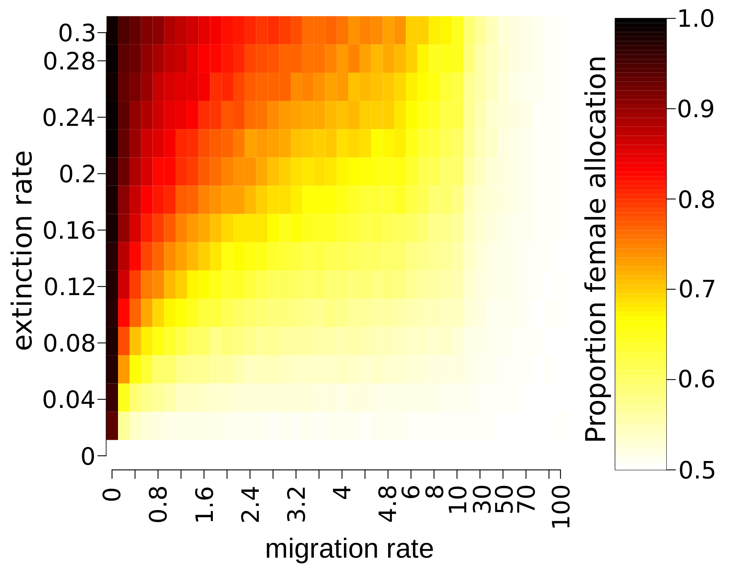

**Figure 1: effect of migration and extinction rates on female allocation**

Colours show the average female allocation measured over the metapopulation at the end of simulations, in a scale lying from 0.5 (white: 50% of female allocation) to 1 (black: 100% of female allocation).

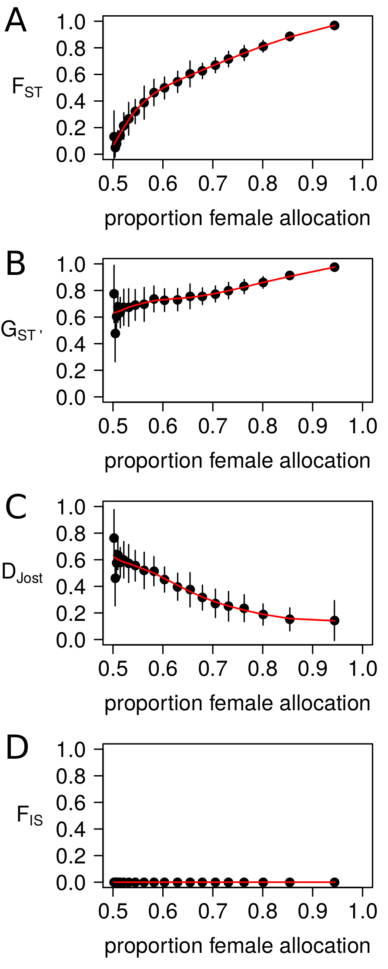

**Figure 2: relations between female allocation and descriptive statistics in population genetics at neutral markers.**

The x-axis shows the measured female allocation at the end of simulations described in figure 1-A.

The y-axis show; FST (**A**), GST' (**B**), Jost's *D* (**C**) and FIS (**D**).  
Each points represent a 5% quantile of the female allocation along the x-axis, and the mean descriptive statistics within each 5% quantile along th e y-axis. Vertical bars represent the standard deviation of the descriptive statistics within each 5% quantile.

The red line represents the loess regression between female allocation and descriptive statistics.

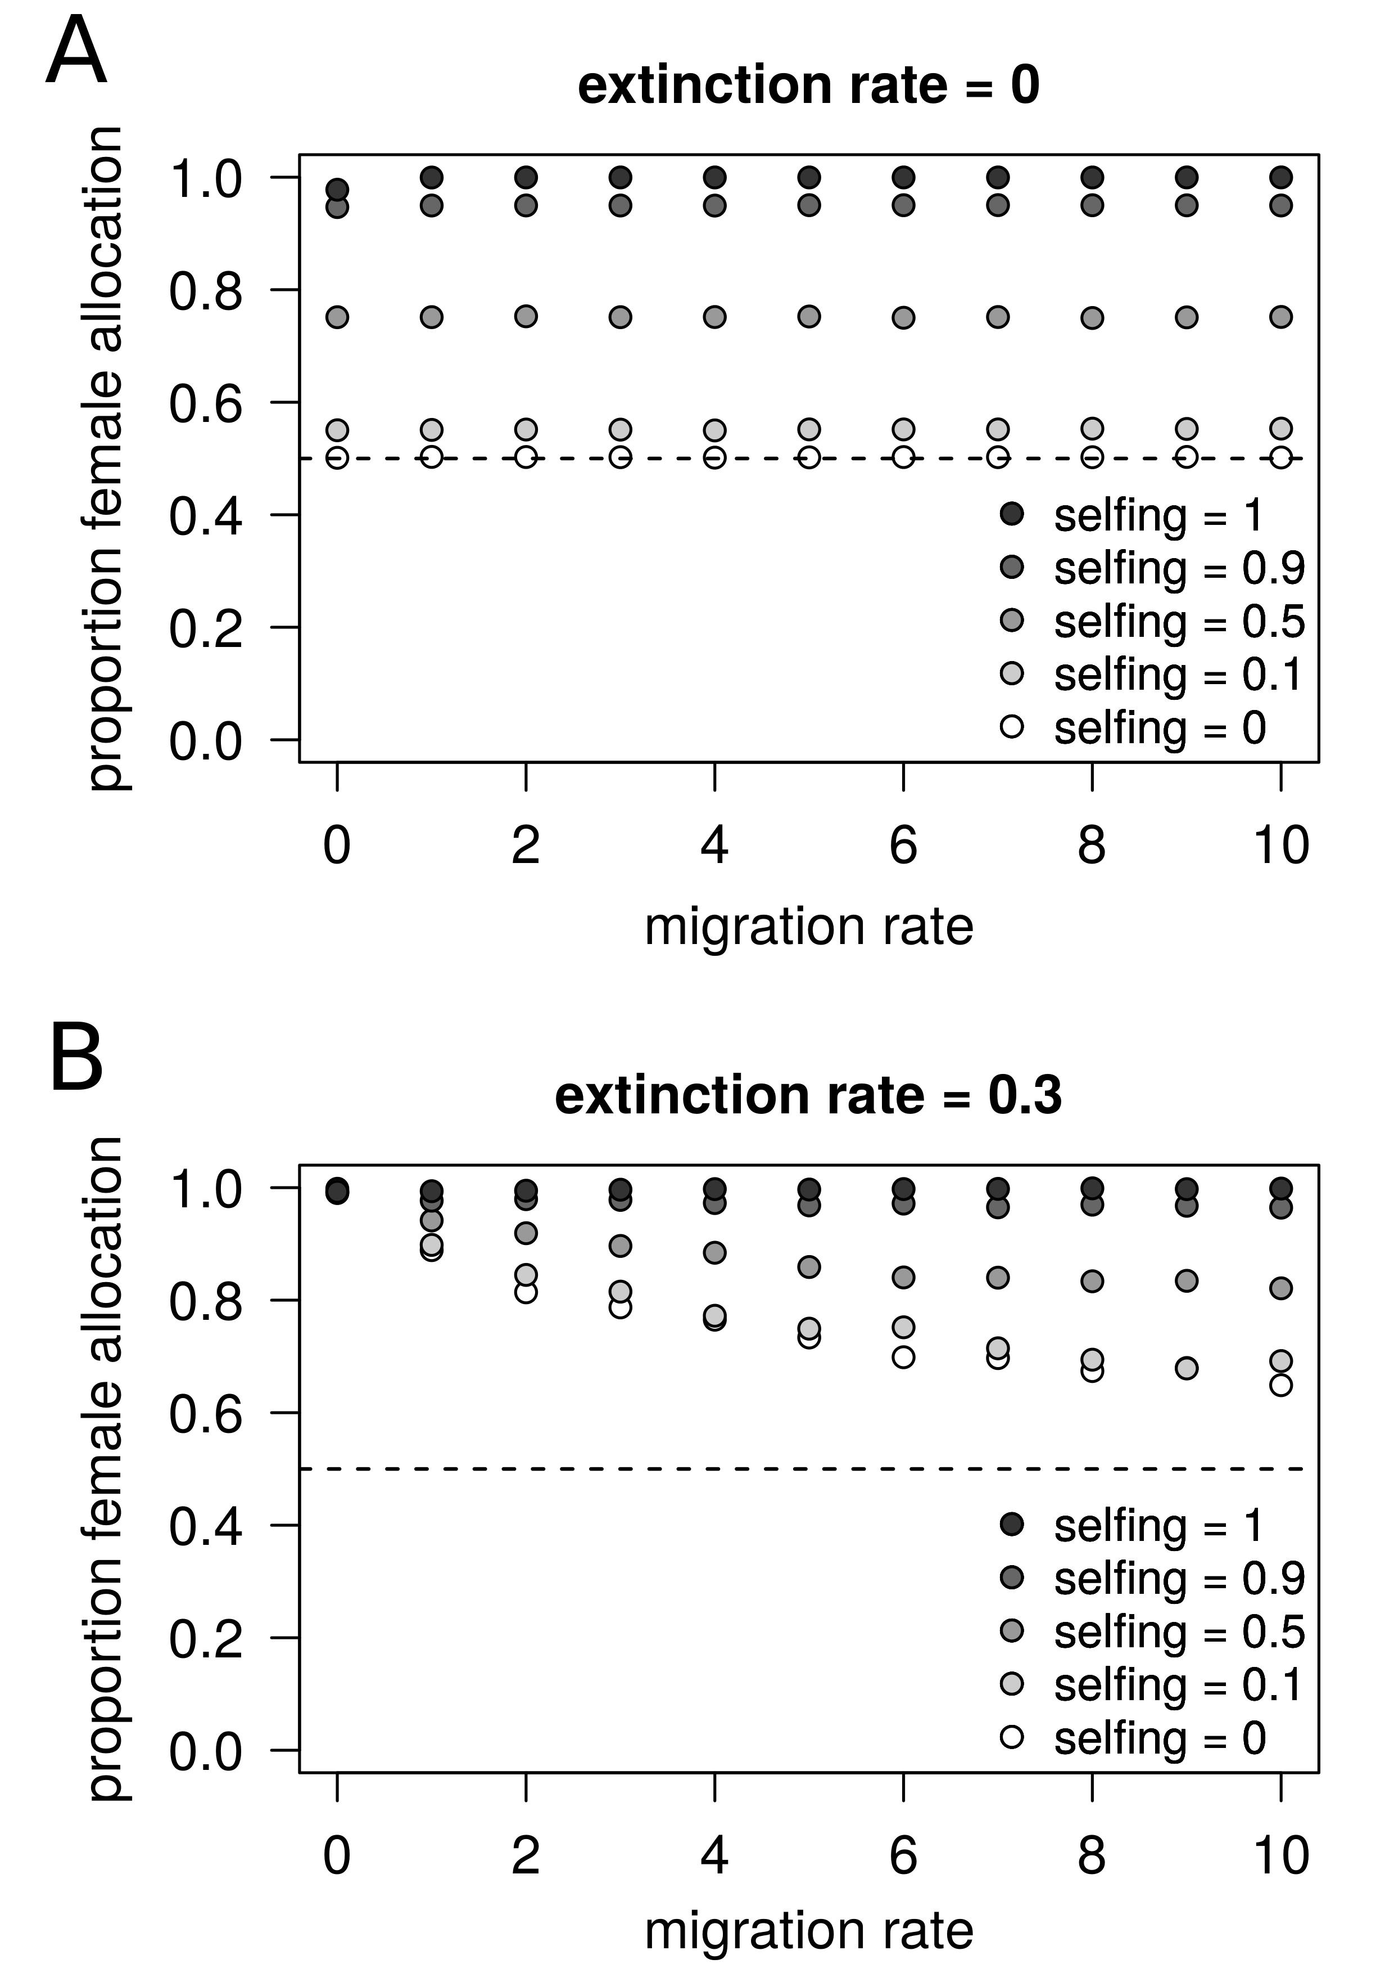

**Figure 3: female allocation in a metapopulation as a function of the migration rate and the base selfing rate of individuals**

The x-axis represent the immigration rates expressed as the mean percentage of individuals coming from random demes in the metapopulation per generation.

The y-axis represent the measured female allocation at the end of simulations.

Dots are represent the average over three independent replicates. Variation over replicates was very small, so that error bars are not shown.

The selfing rate here is the probability for an ovule to be fertilized by a male gamete coming from the same hermaphroditic individual prior to random mating; the realised selfing rate could thus be higher, depending on the population size. Four values of selfing were explored from 0 (white) to 1 (black).

Female allocation is shown when extinction rates are fixed to 0 (panel A) and 0.3 (panel B).

Dashed horizontal line shows female allocation of 50%.

**Supplementary information**

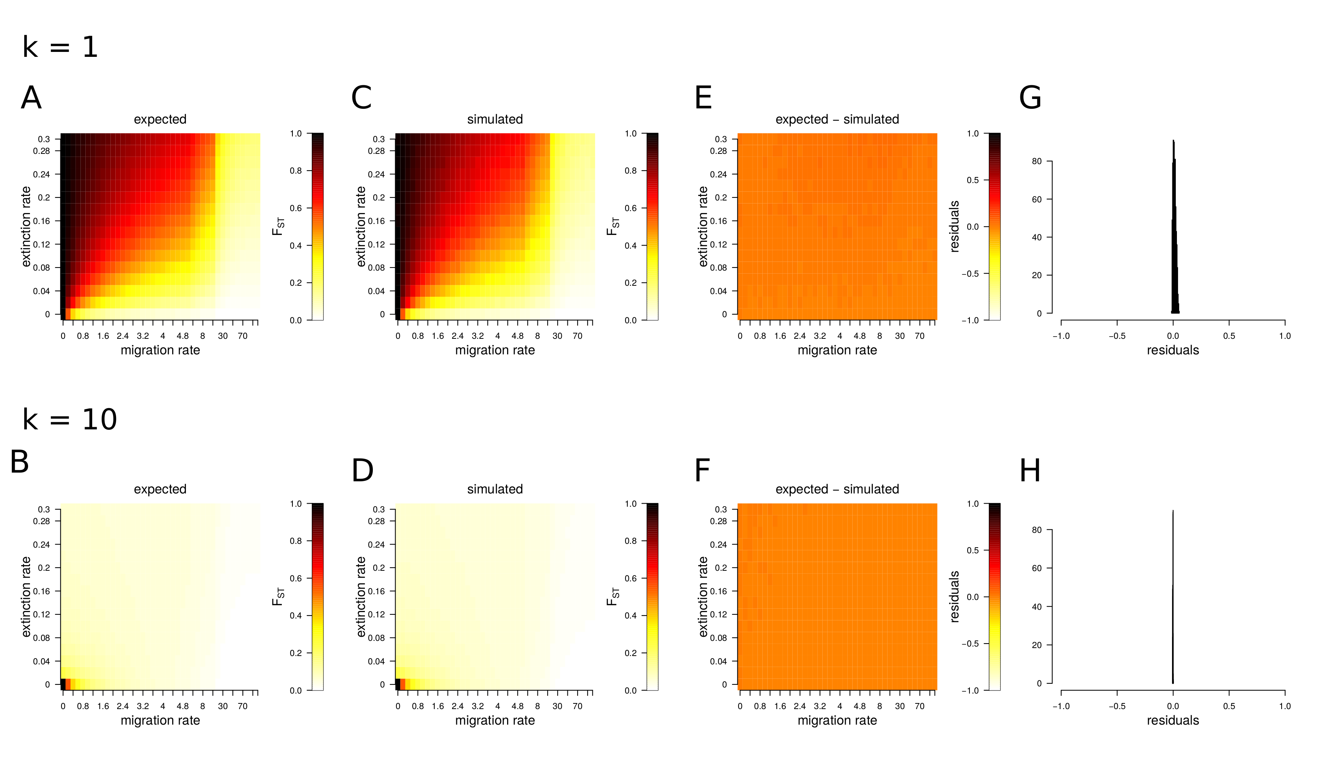

**Figure S1: ability of simulations to produce expected FST values.**

The migration rate is expressed as the mean percentage of individuals coming from random demes in the metapopulation per generation.

The extinction rate is expressed as the mean probability for a deme to become extinct and recolonized per generation.

Here, the number of colonizers is fixed to k = 1.

**A, B.** Analytical expectations following Rousset (2003) for FST as a function migration and extinction. Colours represent FST values lying from 0 (white) to 1 (black).

**C, D.** FST measured at 20 simulated neutral markers after 3,000 generations. 640 grid points were explored with combination of parameters similar to Fig. S1-A. Colours represent FST values lying from 0 (white) to 1 (black).

**E, F.** Residuals are the differences between expected (Fig. S1-A) and simulated (Fig. S1-B) values of FST for all combination extinction and migration rates. Colours represent possible values of residuals (= FST-Expected – FST-Simulated), putatively lying from -1 (white) to 1 (black).

**G, H.** Distributions of residuals over 1,920 simulations (640 combinations of parameters replicated three times).

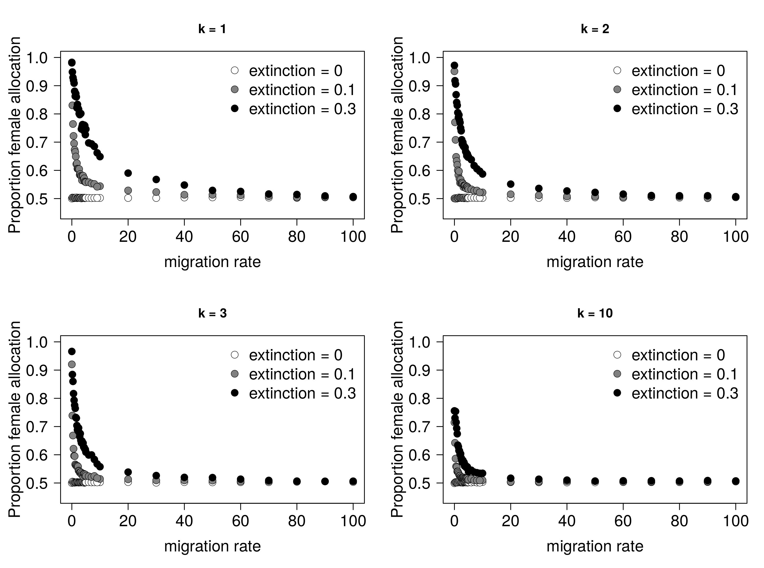

**Figure S2: effect of migration rate and extinction rate on female allocation.**

Results are shown for k=1, k=2, k=3 and k=10 colonizers making the propagule pool.

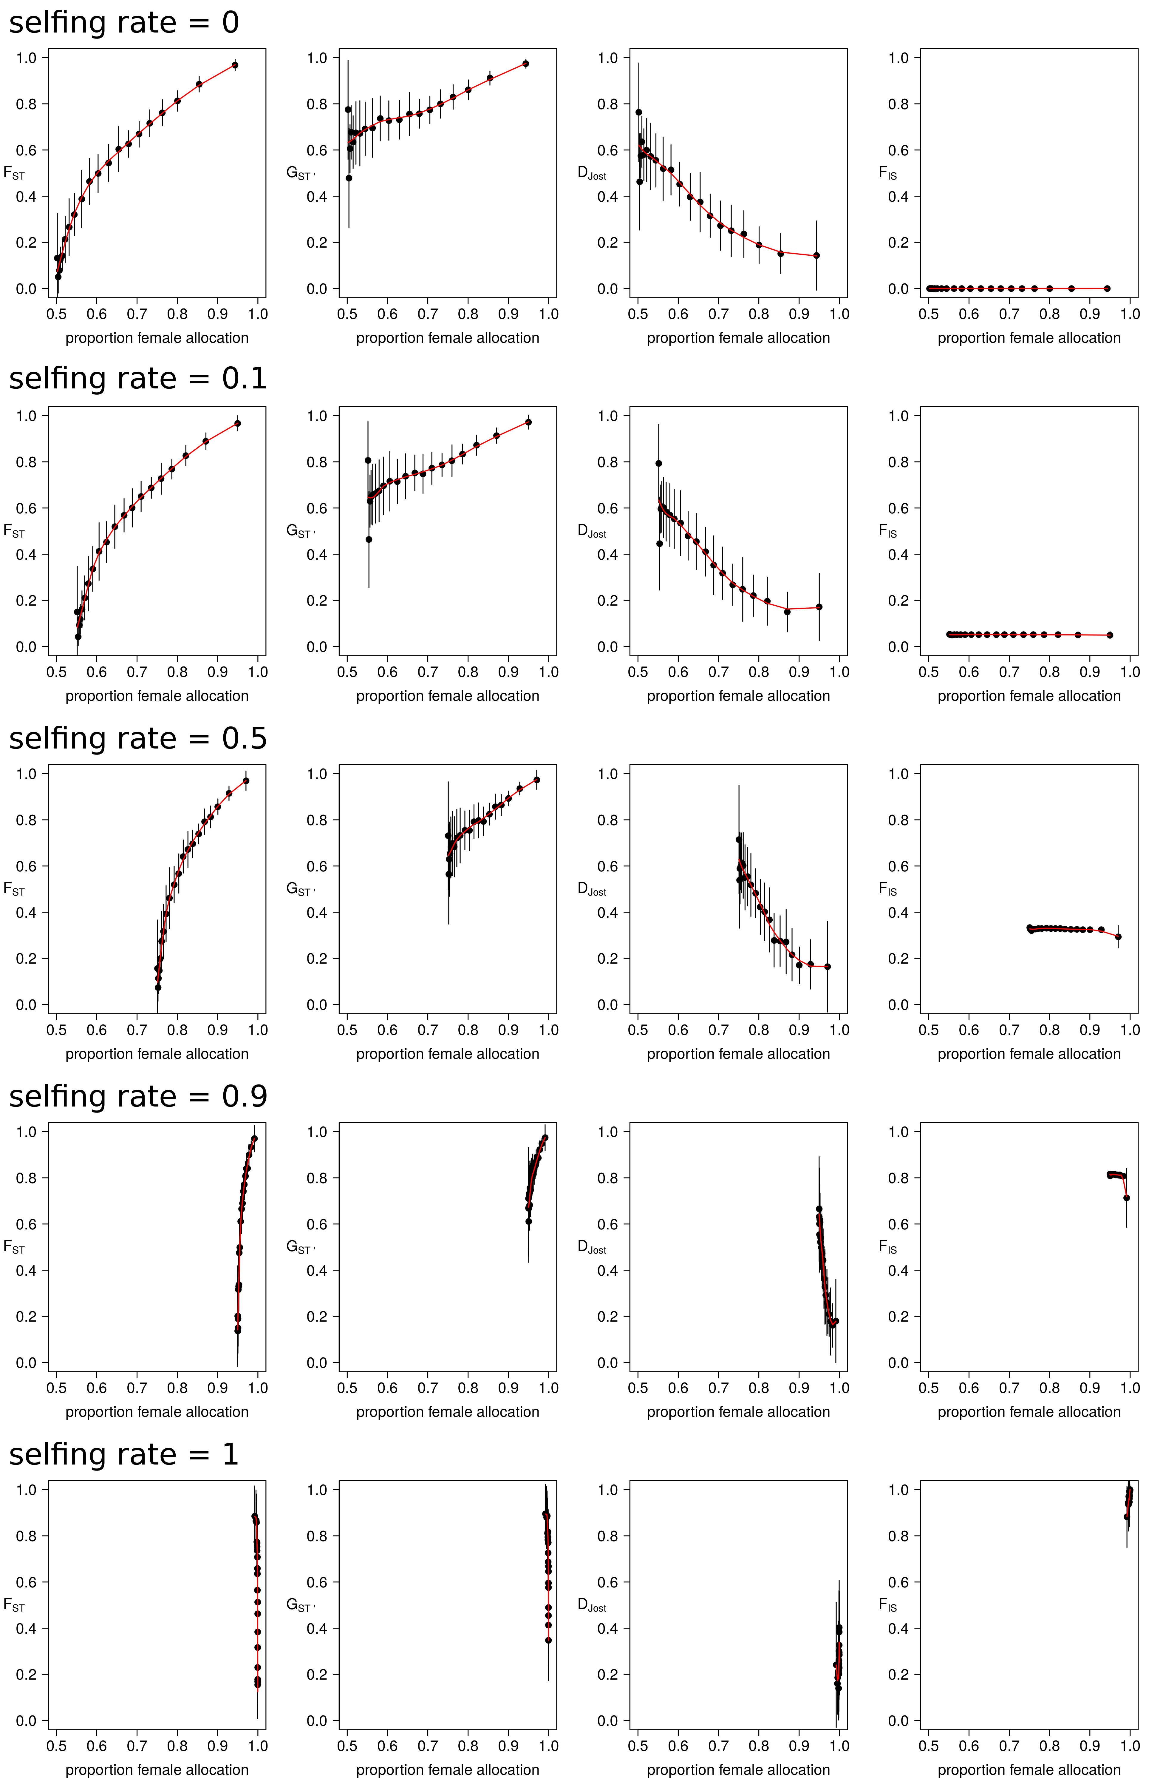**Figure S3: relations between statistics in population genetics at neutral markers and female allocation for different selfing rates.**

For each individual graphic window, the x-axis shows the measured female allocation at the end of simulations.

The y-axis show FST, GST' , Jost's *D* and FIS.

Five different selfing rates were explored:

First row of plots: selfing = 0.

Second row of plots: selfing = 0.1

Third row of plots: selfing = 0.5

Fourth row of plots: selfing = 0.9

Fifth row of plots: selfing = 1

Each points represent a 5% quantile of the female allocation along the x-axis, and the averaged descriptive statistics within each 5% quantile along the y-axis. Vertical bars represent the standard deviation of the descriptive statistics within each 5% quantile.

The red line represents the loess regression between female allocation and descriptive statistics.

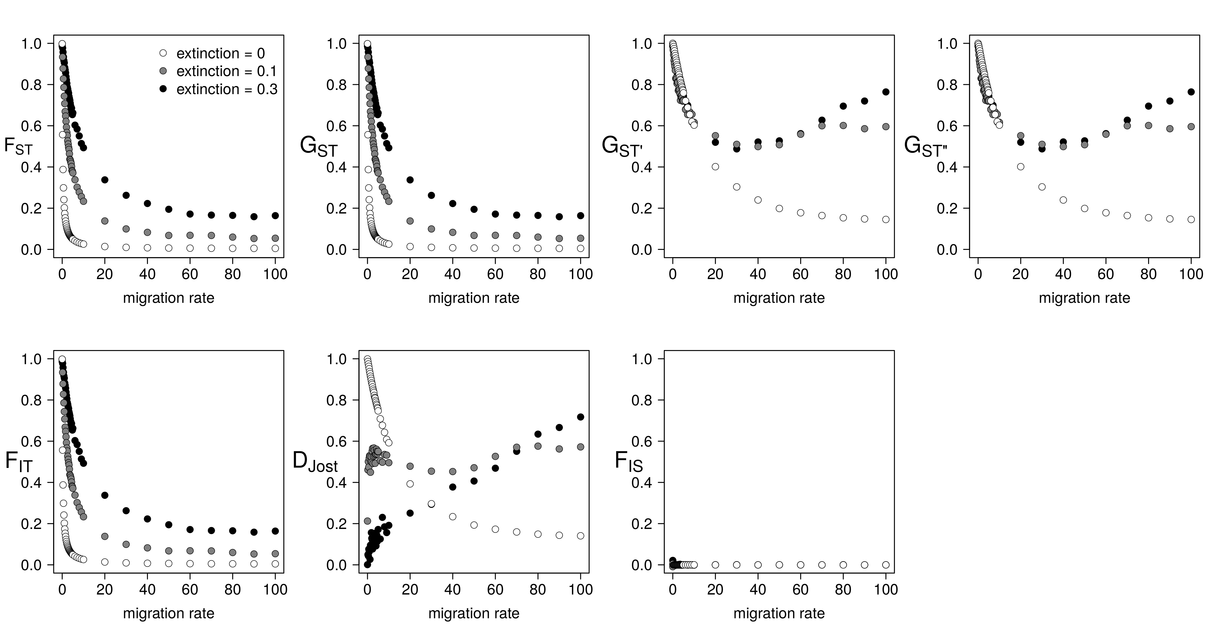**Figure S4: relation between migration rate and 7 statistics in population genetics at neutral markers for k = 1 colonizer**

**F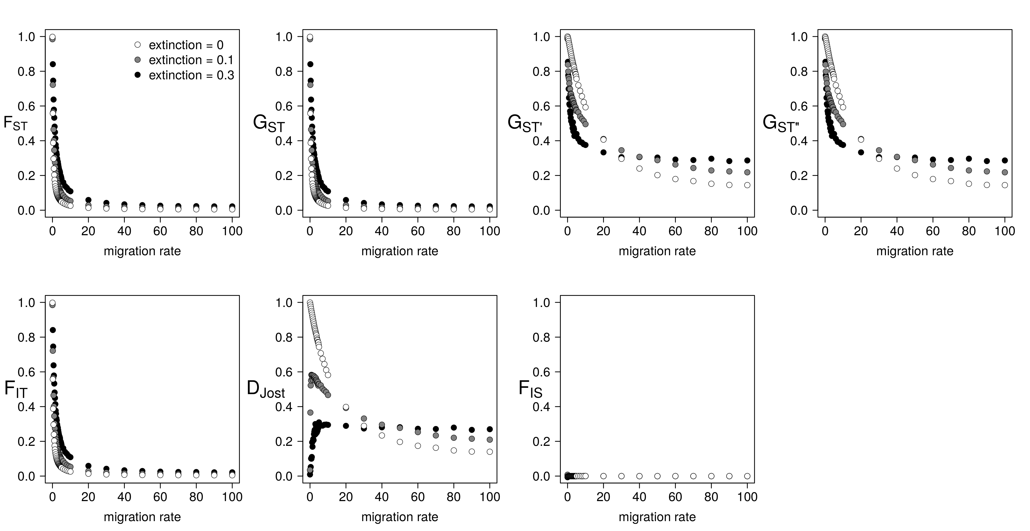igure S5: relation between migration rate and 7 statistics in population genetics at neutral markers for k = 10 colonizers**

**Table S1. Statistics measured during simulations**